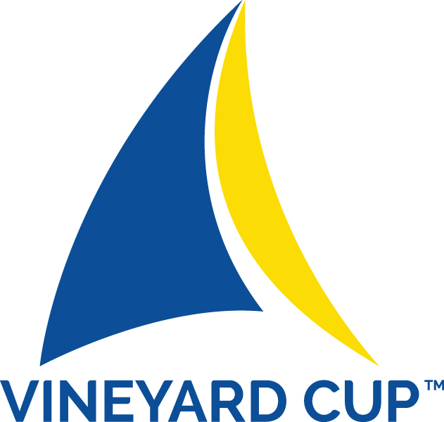

2018 NOTICE OF EXPECTATIONS

THE SAIL MARTHA’S VINEYARD VISION:
As an organization that places its passion and respect for the sea that surrounds its island home above all else, Sail Martha’s Vineyard seeks to develop and promote an environmentally responsible and economical event model of sustainability that becomes the standard, not only on Martha’s Vineyard but, over time, across the entire United States sailing community.

SAIL MARTHA’S VINEYARD’S SUSTAINABILITY POLICY:

Sail Martha’s Vineyard will operate in an environmentally responsible manner at all times and with all of its programs, both on the water and ashore. We will seek to position Sail Martha’s Vineyard as the leading marine environmental and sustainability advocate and educator on the Island of Martha’s Vineyard.

SAIL MARTHA’S VINEYARD COMMITS TO:
- Continue to honor, further develop, implement and promote its LOCALLY Sourced / ZERO Waste event management model for which 11th Hour Racing, Sail Martha’s Vineyard’s sustainability partner, provided the seed funding.
- Honor 11th Hour Racing’s www.11thhourracing.org mission to promote collaborative systemic change for the health of our marine environment.
- Meet Sailors for the Sea’s Platinum Level Regatta Standard www.sailorsforthesea.org
  - Having an effective Green Team in the Race Village
  - Educating the Vineyard Cup fleet to the environmental challenges facing all of us relating to the health of our oceans
  - Creating a paperless event; The NOR, Sailing Instructions, Course Diagrams, Scratch Sheets, Scoring Results and this Notice of Expectations will be available only on-line
  - Creating a tradition of sustainability at every Vineyard Cup that will have a dynamic impact on ocean health
  - To award trophies that can be used and enjoyed
  - To provide access to potable water at water refilling stations in the Race Village
  - To serve only locally sourced (within ten miles of Martha’s Vineyard) sustainable foods
- Use only re-usable dinnerware…plates, glasses, silverware and the like
- Collect and segregate any materials/containers that can be recycled and deliver them to the appropriate entry point for recycling on the Island
- Collect all food waste products and coordinate its use with the farming community
- Collect all returnable containers and deliver them to the appropriate waste stream entry point for their recovery
- Establish a strategy to preclude the accumulation/co-mingling of garbage/trash
- Eliminate single use bags…provide re-usable bags that will actually get used again and again
- Provide simple and re-usable signage
- Promote the use of Vineyard Transit Authority busses www.vineyardtransit.com
- Work with Tisbury Waterways to better promote the need to better control storm water runoff
- Work to calculate and value carbon offsets
- Support our harbormasters to assure that all local “no discharge” regulations are honored and pump-out boats utilized.
- Require that no vessel use cleaning materials to wash down their boat after racing. Our mantra is “water only”
- Provide and explain the use of absorbent pads for every boat as a safety mechanism against fuel spills
- Require that no hull cleaning is done inside the harbor
- Promote the use of more fuel efficient motors and boats and the use of alternative fuels
- Environmental responsibility promotes healthy oceans which promote healthy marine Biosystems

- SAIL MARTHA’S VINEYARD ASKS YOU TO COMMIT TO:
  - Environmentally responsible harbor and shorefront practices.
    - No in-harbor bottom washing
    - No use of single serve plastic water bottles
    - Using fuel absorbent pads around fuel tank fill hole when refueling
    - Honor all laws and regulations with regard to dumping anything overboard
    - Separate (please don’t co-mingle) your on board trash into returnables, recyclables, compostables and reusables and place them in the appropriate containers at the Race Village waste collection tent
  - Respect what we are seeking to accomplish for all sailors…this is not a contest but a serious attempt to make a difference in the health of our oceans
  - Work with us to establish the LOCALLY Sourced / ZERO Waste event management model as the standard at all major regattas around the United States…SPREAD THE WORD!!
  - Support the efforts of the kids on the Green Team in the Race Village
  - Honor the Vineyard Cup Regatta environmental standards
  - Share with us any ideas you might have to make the LOCALLY Sourced / ZERO Waste event management model even better

Most importantly, have fun

